Casualty Data Analysis

  - National and Local Context

KSI Casualties, Lancs 14 and Great Britain; 2007-2016 (Fig 1)
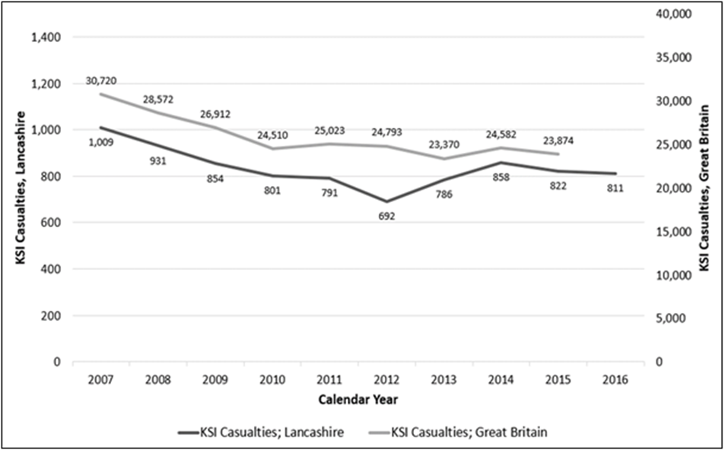

The overall trend in number of KSI casualties in Lancashire has been broadly in line with the downward national trend seen over the last 10 years; with the lowest number occurring in 2012. Subsequently there was an increase in the 2 years 2013 to 2014; followed by a levelling off, in line again with the national trend.

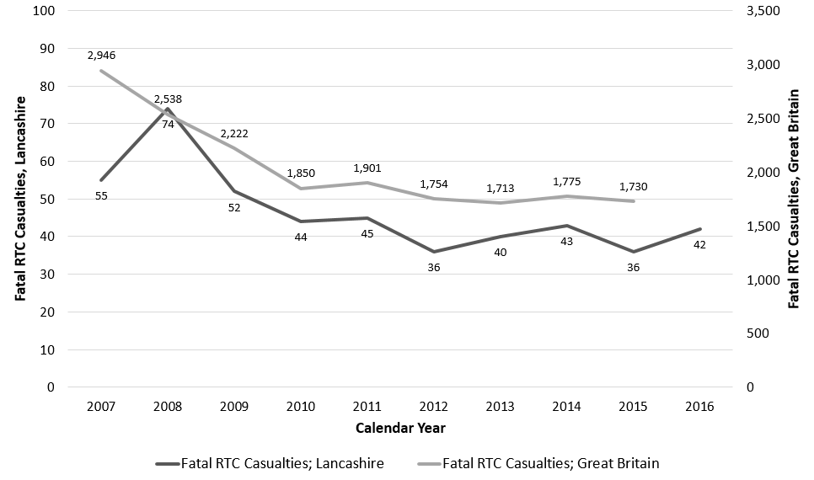
Fatally Injured Casualties, Lancs 14 and Great Britain; 2007-2016 (Fig 2)
Similarly the overall trend in fatally injured casualties in Lancashire has mirrored the national trend over the last 10 years; although in both cases the rate of decrease has stalled since 2012.

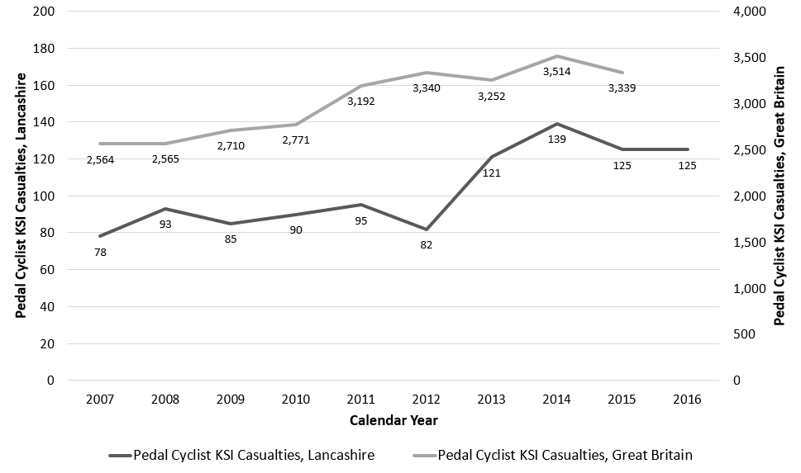
Pedal Cyclist KSI Casualties, Lancs 14 and Great Britain; 2007-2016 (Fig 3)

The overall trend in number of pedal cyclist KSI casualties has increased both nationally and across Lancashire over the last 10 years; and in particular during 2013 and 2014. Both nationally and locally, cycle mileage is reported to have increased over this time.

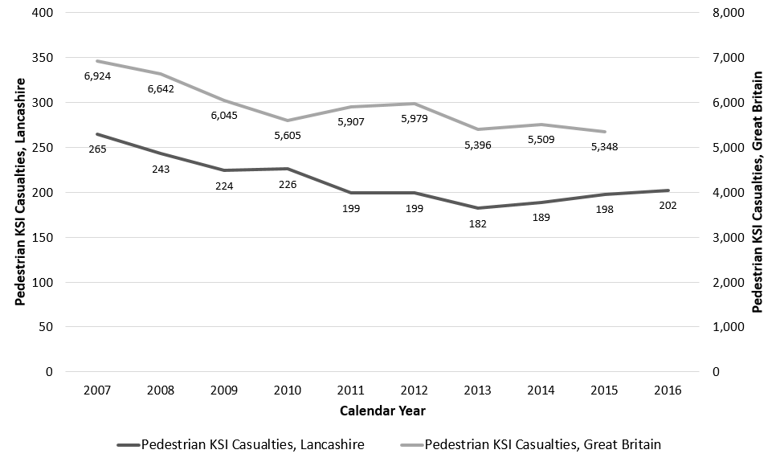
Pedestrian KSI Casualties, Lancs 14 and Great Britain; 2007-2016 (Fig 4)
The overall trend in pedestrian KSI casualties decreased both nationally and locally between 2007 and 2013; with pedestrian KSI casualties across Lancashire showing a slight year on year increase since 2013, whilst the national trend in general levelling.

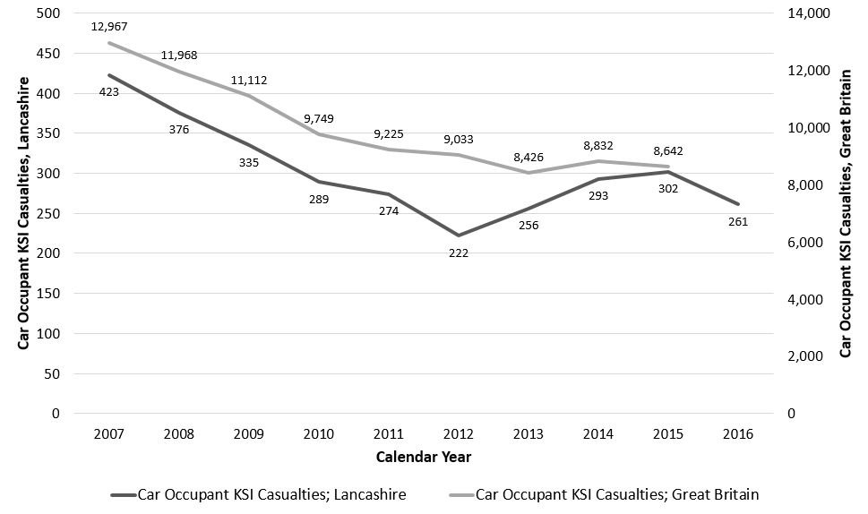
Car Occupant KSI Casualties, Lancs 14 and Great Britain; 2007-2016 (Fig 5)

The overall trend in car occupant KSI casualties shows a decrease both nationally and locally over the years 2007 to 2012; although since 2012 this casualty group shows an increase in Lancashire, whilst nationally the numbers of such casualties have remained broadly similar.

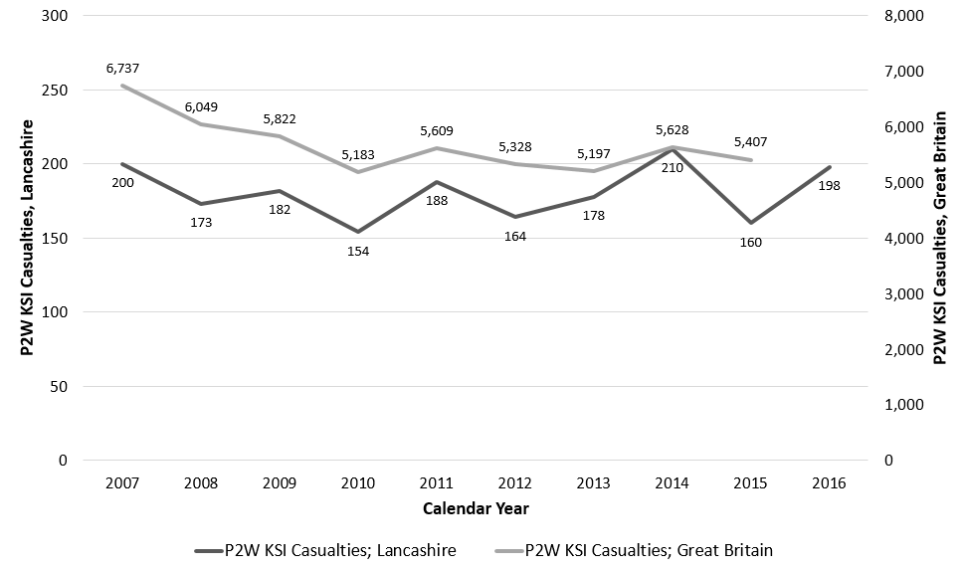
Powered 2 Wheel (P2W) KSI Casualties, Lancs 14 and Great Britain; 2007-2016 (Fig 6)
The overall trend in P2W KSI casualties has decreased nationally, but locally remained broadly similar over the last 10 years; with variations year to year and an overall increase since 2010.

1.2 Who are the Casualties in Lancashire?

Adult and Chid KSI Casualties, Lancs 14; 2012-2016 (Fig 7)
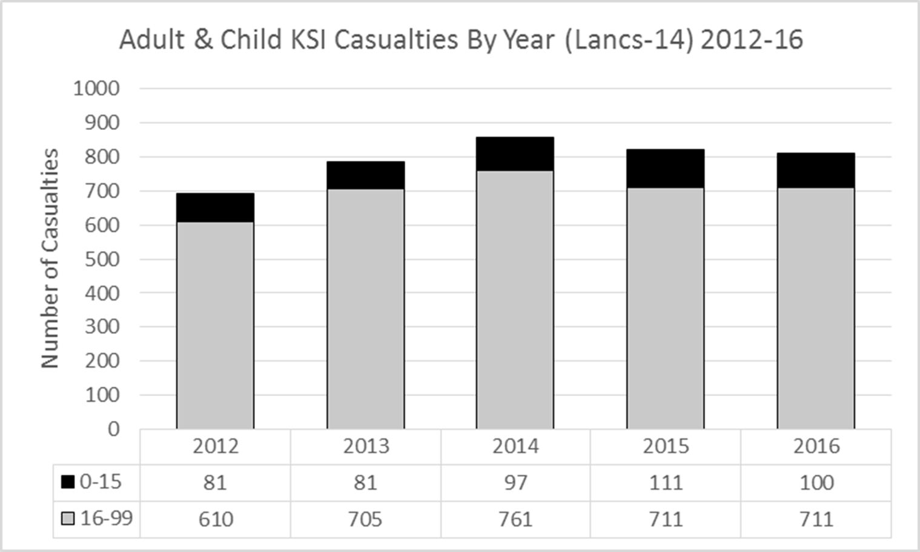

KSI Casualties by Age, Lancs 14; 2012-2016 (Fig 8)
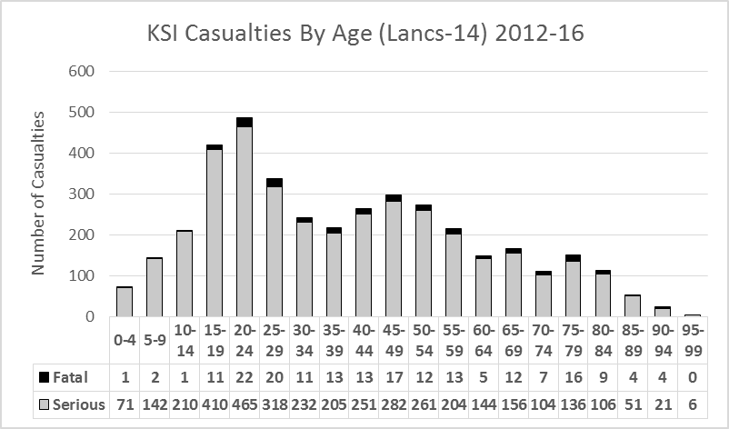

More detailed analysis of the ages of the KSI casualties in Lancashire indicates high numbers of younger adult casualties in general and in particular relating to car occupancy.

Pedestrian casualties are particularly prevalent amongst school aged children with the younger secondary school aged children having the highest numbers of pedestrian casualties.

Pedal cyclist casualties are spread across the age groups from secondary school aged children to those aged in the late fifties.

Casualties amongst P2W users show two distinct groupings, the most significant number being young riders aged between 16 – 24 years, followed by those between 40 and 54 years of age.

The more vulnerable road users i.e. pedestrians, cyclists and P2W account for 62% of KSI casualties.

KSI Casualties by Casualty Group, Lancs 14; 2012-2016 (Fig 9)
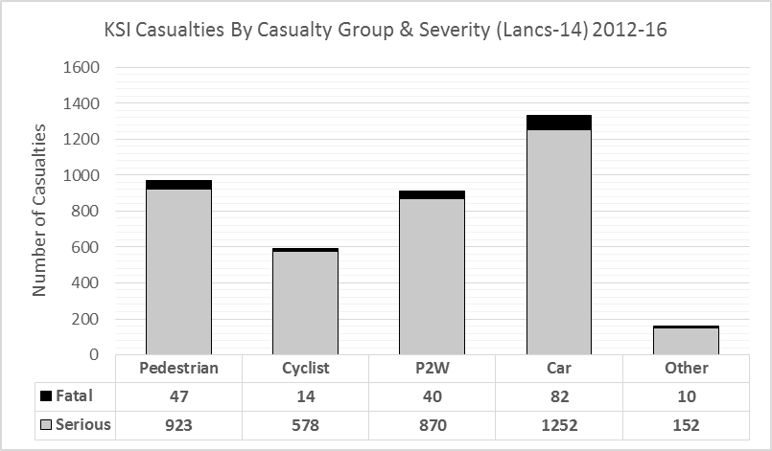

The more vulnerable road users i.e. pedestrians, cyclists and P2W account for 62% of KSI casualties.

The 'other' group covers a range of modes including LGV/HGV drivers, bus occupants, agricultural vehicle drivers, horse riders and mobility scooter drivers.

When slight injuries are also taken into consideration, car occupants are the largest group of casualties, accounting for 62% of all casualties in Lancashire.

1.3 Where are the Casualties in Lancashire?
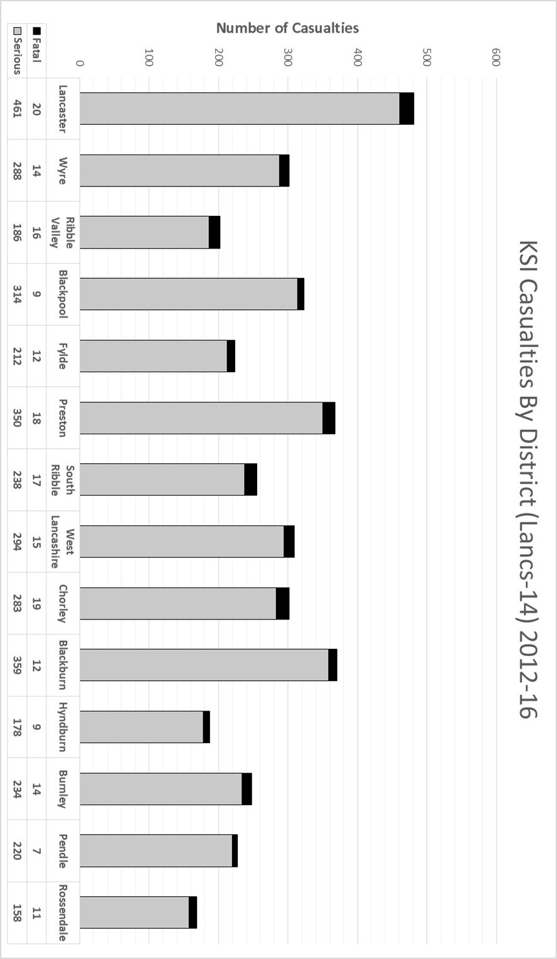
1.4 When are Casualties Occurring in Lancashire?

KSI Casualties by Month, Lancs 14; 2012-2016 (Fig 11)
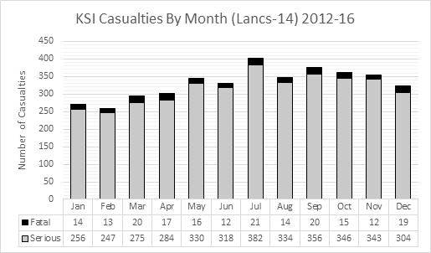

The month with the highest number of cumulative KSI casualties is July, with casualties predominantly occurring during the autumn months.
The number of KSI casualties by day of the week show little variation.

KSI Casualties by Hour, Lancs 14; 2012-2016 (Fig 12)
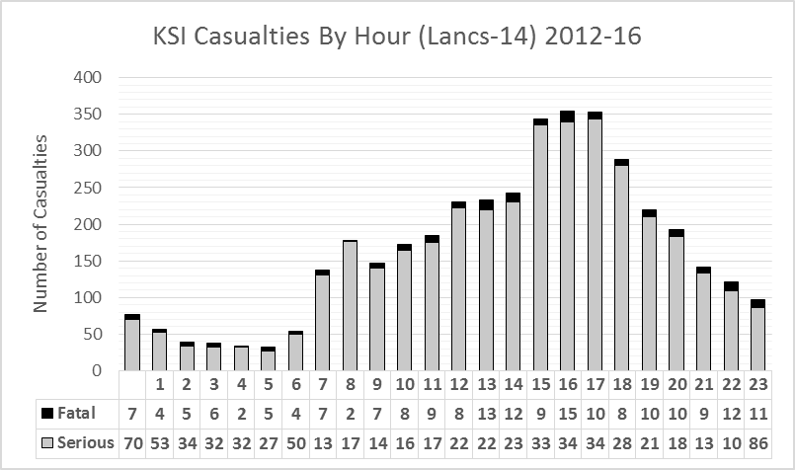
Most casualties occur in the afternoon/evening peak travel period, corresponding to school closing times and through the general commute home between 3pm and 6pm.

1.5 Further Analysis

The above trends and profiles are a high level view based on absolute numbers of casualties in Lancashire. Further analysis has been conducted to inform prioritisation and targeting of interventions, including:

- Cluster & route analysis.
- Casualty rates per head of population.
- In depth studies of casualty groups, e.g. cyclists, child pedestrians and older road users.
- Mosaic profiling of high risk casualty groups to provide a more detailed picture of who the casualties are in terms of accommodation, family groups, employment status and preferred means of communication.

